**6.1 Business Rules**

An account can reserve many books. A book reservation belongs to only one account.

An account can make payment on many fine. A fine can only be paid by one account.

A book reservation can reserve many books. A book can be reserved by many books.

A book reservation can have one or no fine. A fine only belongs to a book reservation.

A report obtains all information from payment record.

A report obtains all information from book reservation record.

**6.2 ERD Diagram**

**6.2.1 Initial ERD**

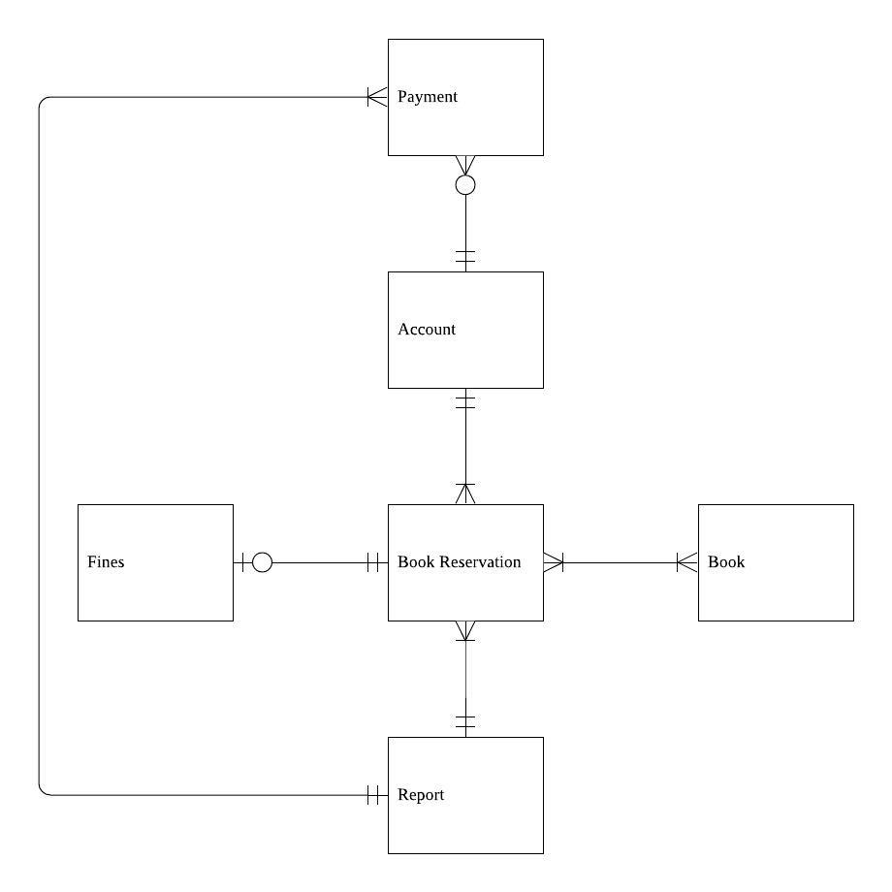

**6.2.2 Final ERD**

